QTenders User Guide

How to register as a supplier

February 2019
Version – 1.1

Document History

Version | Date | Status | Key changes made | Author/s | Reviewer/s
1 | Oct 2018 |  |  | SG
1.1 | Feb 2019 |  |  | RL

Table of Contents

QTenders User Guide 1

How to register as a supplier 1

Document History 2

Table of Contents 3

Overview 4

Registration Process 4

Terms and conditions 4

Trading information 5

Supplier Contact Information 8

Regions 9

Products and Services 10

Completing the registration 10
Errors 10
Confirming registration details 12
Check the details. 12
Registration confirmation 12

Appendix 1 – Region breakdown 13

Overview
This guide is intended to provide detailed information to suppliers on how to register with the QTenders system.
If you work for a Queensland Government Agency and want to issue, manage or close tenders or contracts then you will need an Agency Account. Please contact the QTenders System Support team on 07 3215 3699.

Registration Process
To start the registration process please click on the ‘Suppliers’ link under the ‘Register’ heading in the left hand menu or on the ‘Register Here’ link on the Home page.
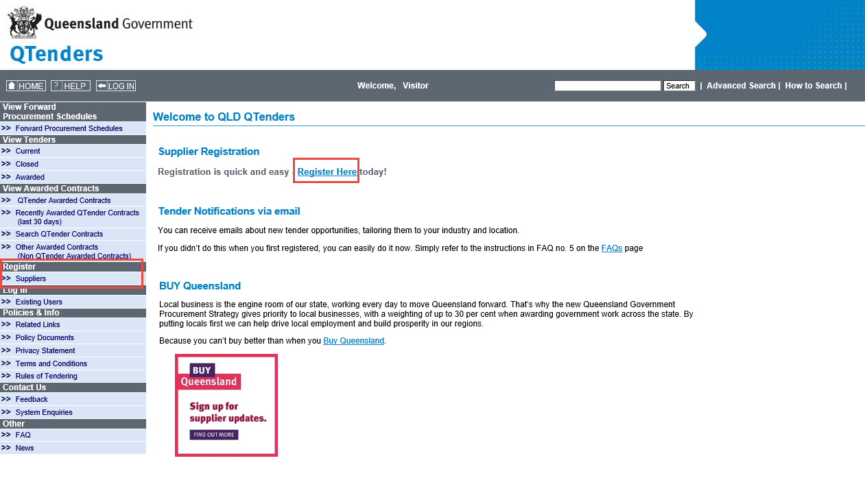

Terms and conditions
At the bottom of the ‘Terms and Conditions’ page you have two buttons, ‘I AGREE’ and ‘I DISAGREE’.
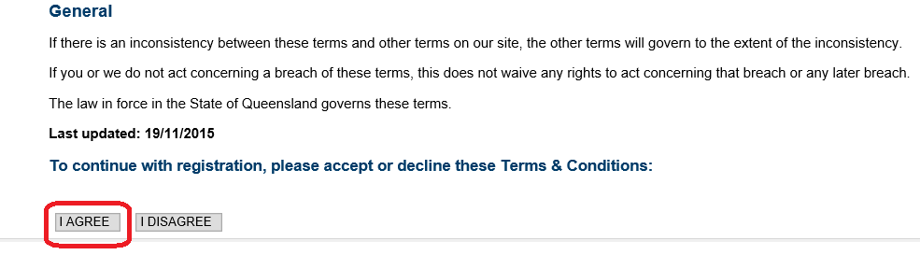

If you click the ‘I DISAGREE’ button then you will be taken back to the Home page and will not be able to register until your agree.
In order to complete a registration and use the QTenders system you must agree to the standard terms and conditions. After reviewing the ‘Terms and Conditions’ page, click the ‘I Agree’ button at the bottom of the page.
The ‘Register New Supplier’ page (online form) will be displayed to continue the registration process.

Trading information
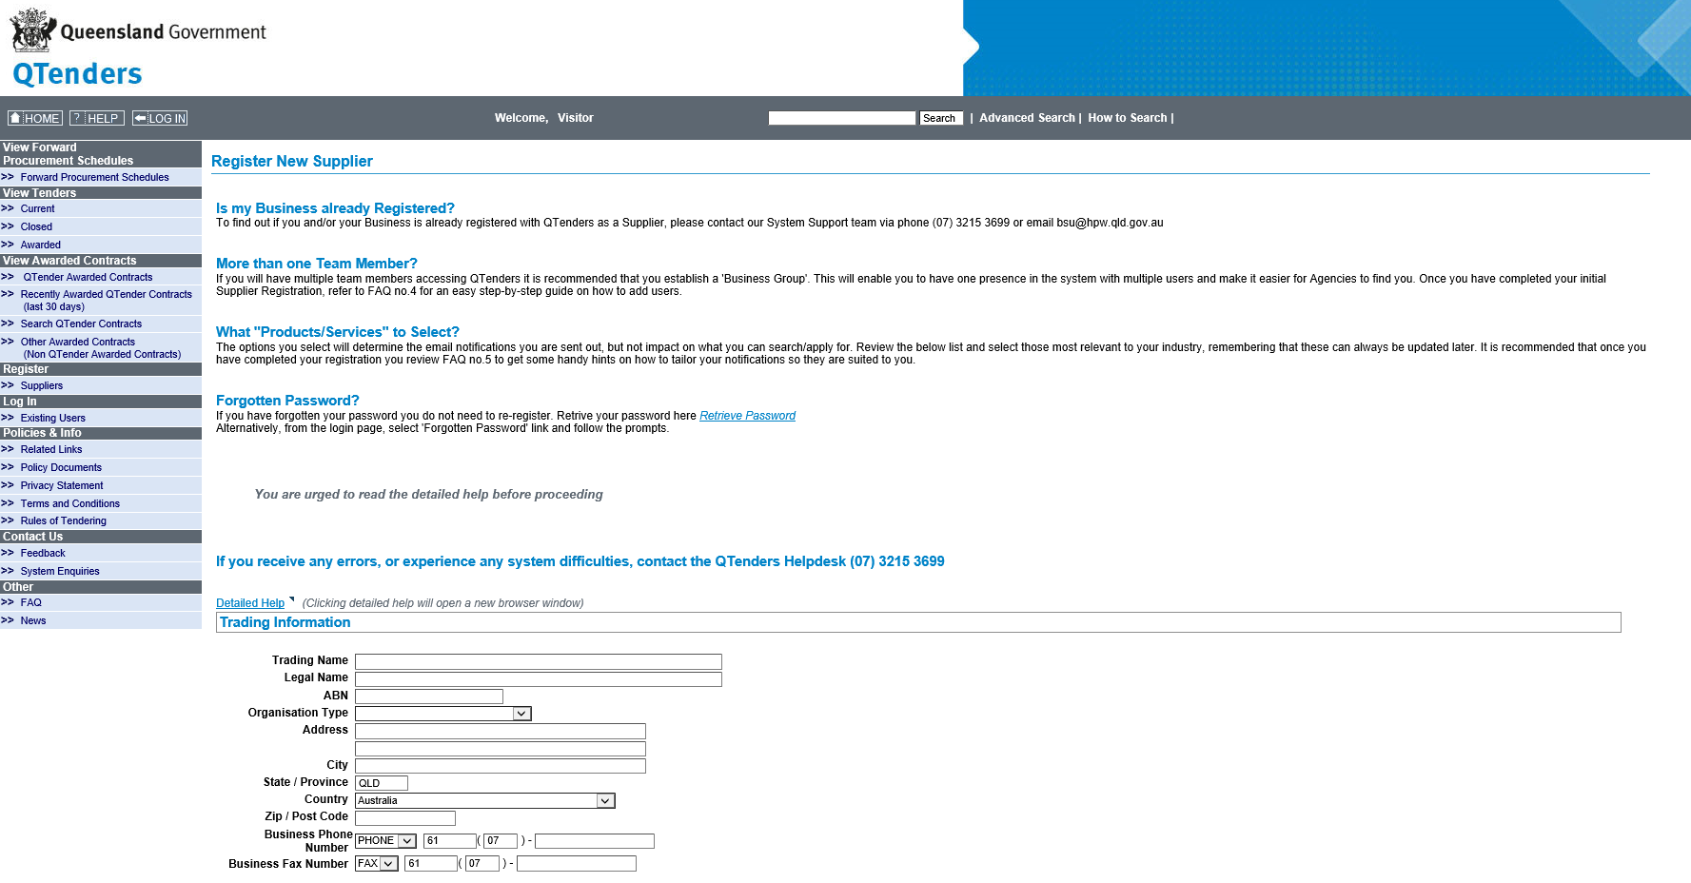
Field (* indicated mandatory) | Description
Trading Name * | The Trading Name is the name normally used to identify your business publicly. If you are a registered business then this will be the name that would appear on any invoices. If you are not a registered company please use, please use your first and last name.
Legal Name * | This is the official registered name. If you are a registered Australian business, this will be the name associated with the company’s ABN. If you are not a registered company, repeat your first and last names.
ABN | All registered Australian Businesses have an Australian Business Number (ABN). Please enter the number if applicable without spaces. If you don’t have an ABN leave this field blank.
Organisation Type * | Commercial Australian Supplier – Any Australian organisation or sole trader supplying goods or services.  Commercial International Suppler – International business based outside of Australia, including charities.  Government Organisation - If you belong to any government organisation, Queensland government or not.  Public (Non-Business) – A general member of the public, not a charity or business.  Researcher – If you are registering for information purposes only, and don’t intend to tender.
Address * | Enter the business street address here.
City | Enter the city where the street address is located.
State/Province | This defaults as Qld, but can be edited to any character abbreviation, up to 3 characters.
Country * | This defaults as Australia, but can be changed to any from the drop down list.
Zip / Post Code | This is the mail post code for the street address of the business.
Business Phone Number * | Business Phone Number  - The first box allows you to choose ‘Phone’ or ‘Mobile’.  Phone  - The second box defaults to the Australian international dialling code, this can be edited.  - The third box defaults to the Qld dialling code, this can be edited.  - The last box allows the phone number to be entered, please do not use spaces.  Mobile  - The first box defaults to blank, please leave this as blank.  - The second box defaults to blank, please leave this as blank.  - The last box allows the 10 digit phone number to be entered, please do not use spaces.
Business Fax Number | - The first box only has a ‘FAX’ option  - The second box defaults to the Australian international dialling code, this can be edited.  - The third box defaults to the Qld dialling code, this can be edited.  - The last box allows the phone number to be entered, please do not use spaces.

Supplier Contact Information

Field (* indicates mandatory) | Description
First Name * | The given name of the new user
Last Name * | The Surname of the new user
Position | Please enter the Position your position in your company, (this is not a mandatory field can be left blank)
Username * | This will be what the user will log on with to access the QTenders system. i.e. (email address, first name.surname) and must be unique. If the username has already been used you receive a warning and need to change it)
Email Address * | Enter a valid email address to receive your username and password details and all future correspondence. If the system says the email is not valid, please check if there is a space at either the front or end of the email.
Phone Number | This is where you can add one other contact number for the new user that is different to the Trading Information.  The first box has 5 options:  Office  - This is where you can add another phone number if it is different to the Trading Information  - The second box defaults to the Australian international dialling code, this can be edited  - The third box defaults to the Qld dialling code, this can be edited  - The last box allows the phone number to be entered, please do not use spaces  Fax  - This where you can add a fax number for the new user, if different to the Trading Information  - The second box defaults to the Australian international dialling code, this can be edited  - The third box defaults to the Qld dialling code, this can be edited  - The last box allows the phone number to be entered, please do not use spaces  Home  - This is where you can add a home phone number for the new user, if desired  - The second box defaults to the Australian international dialling code, this can be edited  - The third box defaults to the Qld dialling code, this can be edited  - The last box allows the phone number to be entered, please do not use spaces.  Mobile  - This is where you can add a mobile phone number for the new user, if desired  - The second box defaults to blank, please leave this as blank  - The third box defaults to blank, please leave this as blank  - The last box allows the 10 digit phone number to be entered, please do not use spaces.  Phone  - This is where you can add an additional phone number for the new user, if desired  - The second box defaults to the Australian international dialling code, this can be edited  - The third box defaults to the Qld dialling code, this can be edited  - The last box allows the phone number to be entered, please do not use spaces.

Regions
This information is used for notifying you of new tenders and indicates where your company provides goods and/or services to. Select the appropriate regions, by clicking the map or tick boxes from the list below the map. A minimum of one region must be selected.
The regions are:
- Cairns & Far North Queensland
- Mount Isa & North West Region
- Townsville
- Mackay/Whitsunday Region
- The Central West
- Rockhampton
- Gladstone
- South West and Darling Downs
- South East Queensland
For a breakdown of which local governments are in each region please refer to appendix 1.
Please note that if a tender is State Wide then it will go out to all regions.

Products and Services
In this section you can select the categories relevant for your business, notifications will be emailed to you of relevant tenders that have been released within the past 24 hours. These categories are very broad, select those that are relevant for your business. If you select all the categories you will receive one email with all the tenders released in the last 24 hours.
After your account has been created you can login and refine your categories or create custom notifications, refer to Q05 in the FAQ section located in the ‘Other’ section of the left hand menu.

Completing the registration
At the end of the registration process select I’m not a robot and complete the Google ReCAPTCHA correctly and click the ‘Register’ button.
Note: if you are in a area that doesn’t allow access to Google, please contact the support team.
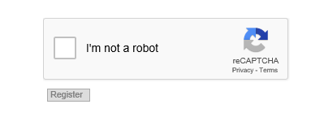

Errors
Upon clicking the ‘Register’ button at the bottom of the page, the system will check the information entered for errors. If there are any problems the fields where attention is required will be highlighted in Red. You may also receive errors or warnings at the top of the page.
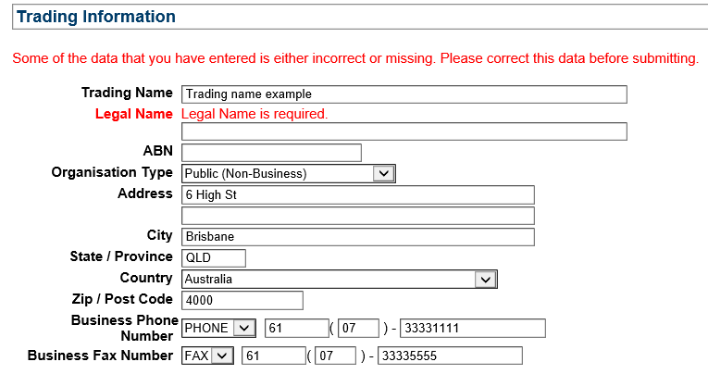
Review and amend any highlighted issues, reselect/unselect the categories again, and click the ‘Register’ button again.
One common error is having a space at the beginning or end of the email address.
Redo the Google ReCAPTCHA correctly then click ‘Register’.
If everything is ok then it will take you to the next page.

Confirming registration details
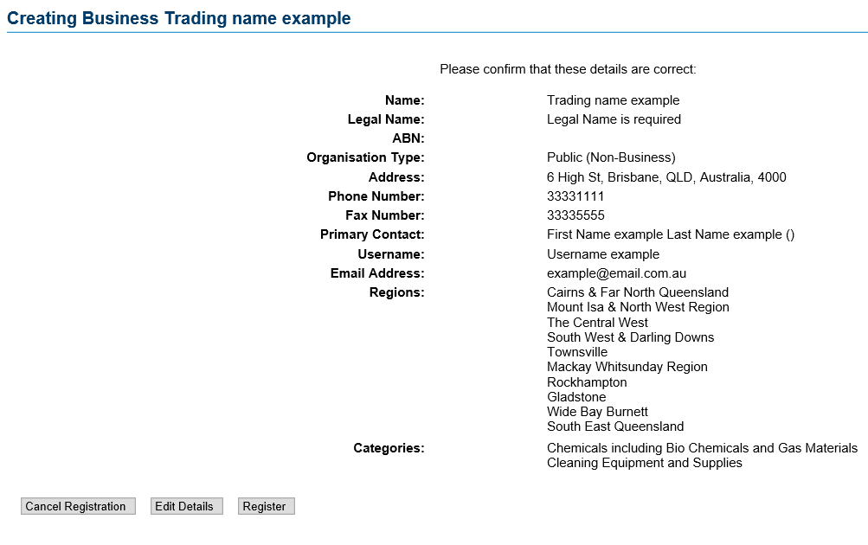

Check the details.
If you decide not to register, click the ‘Cancel Registration’ button or click on the ‘X’ at the top right of the page.
If there are any mistakes in the information that you have entered, then click the ‘Edit Details’ button, this will take you back to the registration form. Correct any mistakes, reselect/unselect the categories again.
Redo the Google ReCAPTCHA correctly then click ‘Register’ to come back to the ‘Creating Business’ page.
Check the data again and if everything is correct click the ‘Register’ button a final time, this will take your to the ‘Created Trading name example’ page.

Registration confirmation
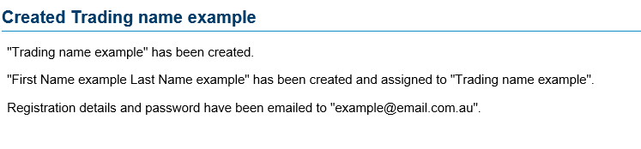
When you select the ‘Register’ button, an automated email will be generated and will be sent to the listed email address containing your user name and temporary password. The confirmation page shows the following details of the registration, Trading Name, first and last names and the email address.
If you do not receive the registration email with your account details, please check that it has not gone into you SPAM or JUNK folders. You may also want to contact your IT department (if you have one) to ensure that the email has not been blocked by the email system used by your company.

Appendix 1 – Region breakdown
List of Regions and the Local Governments within them.
Region | Local Government
Cairns and Far North Queensland | Aurukun Shire Council
Cairns and Far North Queensland | Cairns Regional Council
Cairns and Far North Queensland | Cassowary Coast Regional Council
Cairns and Far North Queensland | Cook Shire Council
Cairns and Far North Queensland | Croydon Shire Council
Cairns and Far North Queensland | Douglas Shire Council
Cairns and Far North Queensland | Etheridge Shire Council
Cairns and Far North Queensland | Hope Vale Aboriginal Shire Council
Cairns and Far North Queensland | Lockhart River Aboriginal Shire Council
Cairns and Far North Queensland | Mapoon Aboriginal Shire Council
Cairns and Far North Queensland | Mareeba Shire Council
Cairns and Far North Queensland | Napranum Aboriginal Shire Council
Cairns and Far North Queensland | Northern Peninsular Area Regional Council
Cairns and Far North Queensland | Pormpuraaw Aboriginal Shire Council
Cairns and Far North Queensland | Tablelands Regional Council
Cairns and Far North Queensland | Torres Shire Council
Cairns and Far North Queensland | Torres Strait Island Regional Council
Cairns and Far North Queensland | Weipa Town Authority
Cairns and Far North Queensland | Wujal Wujal Aboriginal Shire Council
Cairns and Far North Queensland | Yarrabah Aboriginal Shire Council
Gladstone | Banana Shire Council
Gladstone | Gladstone Regional Council
Mackay/Whitsunday Region | Isaac Regional Council
Mackay/Whitsunday Region | Mackay Regional Council
Mackay/Whitsunday Region | Whitsunday Regional Council
Mount Isa and North West Region | Burke Shire Council
Mount Isa and North West Region | Carpentaria Shire Council
Mount Isa and North West Region | Cloncurry Shire Council
Mount Isa and North West Region | Doomadgee Aboriginal Shire Council
Mount Isa and North West Region | Flinders Shire Council
Mount Isa and North West Region | Kowanyama Aboriginal Shire Council
Mount Isa and North West Region | McKinlay Shire Council
Mount Isa and North West Region | Mornington Shire Council
Mount Isa and North West Region | Mount Isa City Council
Mount Isa and North West Region | Richmond Shire Council
Rockhampton | Central Highlands Regional Council
Rockhampton | Livingstone Shire Council
Rockhampton | Rockhampton Regional Council
Rockhampton | Woorabinda Aboriginal Shire Council
South East Queensland | Brisbane City Council
South East Queensland | Gold Coast City Council
South East Queensland | Ipswich City Council
South East Queensland | Lockyer Valley Regional Council
South East Queensland | Logan City Council
South East Queensland | Moreton Bay Regional Council
South East Queensland | Noosa Shire Council
South East Queensland | Redland City Council
South East Queensland | Scenic Rim Regional Council
South East Queensland | Somerset Regional Council
South East Queensland | Sunshine Coast Regional Council
South West and Darling Downs | Balonne Shire Council
South West and Darling Downs | Bulloo Shire Council
South West and Darling Downs | Goondiwindi Regional Council
South West and Darling Downs | Maranoa Regional Council
South West and Darling Downs | Murweh Shire Council
South West and Darling Downs | Paroo Shire Council
South West and Darling Downs | Quilpie Shire Council
South West and Darling Downs | Southern Downs Regional Council
South West and Darling Downs | Toowoomba Regional Council
South West and Darling Downs | Western Downs Regional Council
The Central West | Barcaldine Regional Council
The Central West | Barcoo Shire Council
The Central West | Blackall Tambo Regional Council
The Central West | Boulia Shire Council
The Central West | Diamantina Shire Council
The Central West | Longreach Regional Council
The Central West | Winton Shire Council
Townsville | Burdekin Shire Council
Townsville | Charters Towers Regional Council
Townsville | Hinchinbrook Shire Council
Townsville | Palm Island Aboriginal Shire Council
Townsville | Townsville City Council
Wide Bay Burnett | Fraser Coast Regional Council
Wide Bay Burnett | Gympie Regional Council
Wide Bay Burnett | North Burnett Regional Council
Wide Bay Burnett | South Burnett Regional Council

List of Local Governments and the Regions they belong to.
Local Government | Region
Aurukun Shire Council | Cairns and Far North Queensland
Balonne Shire Council | South West and Darling Downs
Banana Shire Council | Gladstone
Barcaldine Regional Council | The Central West
Barcoo Shire Council | The Central West
Blackall Tambo Regional Council | The Central West
Boulia Shire Council | The Central West
Brisbane City Council | South East Queensland
Bulloo Shire Council | South West and Darling Downs
Burdekin Shire Council | Townsville
Burke Shire Council | Mount Isa and North West Region
Cairns Regional Council | Cairns and Far North Queensland
Carpentaria Shire Council | Mount Isa and North West Region
Cassowary Coast Regional Council | Cairns and Far North Queensland
Central Highlands Regional Council | Rockhampton
Charters Towers Regional Council | Townsville
Cloncurry Shire Council | Mount Isa and North West Region
Cook Shire Council | Cairns and Far North Queensland
Croydon Shire Council | Cairns and Far North Queensland
Diamantina Shire Council | The Central West
Doomadgee Aboriginal Shire Council | Mount Isa and North West Region
Douglas Shire Council | Cairns and Far North Queensland
Etheridge Shire Council | Cairns and Far North Queensland
Flinders Shire Council | Mount Isa and North West Region
Fraser Coast Regional Council | Wide Bay Burnett
Gladstone Regional Council | Gladstone
Gold Coast City Council | South East Queensland
Goondiwindi Regional Council | South West and Darling Downs
Gympie Regional Council | Wide Bay Burnett
Hinchinbrook Shire Council | Townsville
Hope Vale Aboriginal Shire Council | Cairns and Far North Queensland
Ipswich City Council | South East Queensland
Isaac Regional Council | Mackay/Whitsunday Region
Kowanyama Aboriginal Shire Council | Mount Isa and North West Region
Livingstone Shire Council | Rockhampton
Lockhart River Aboriginal Shire Council | Cairns and Far North Queensland
Lockyer Valley Regional Council | South East Queensland
Logan City Council | South East Queensland
Longreach Regional Council | The Central West
Mackay Regional Council | Mackay/Whitsunday Region
Mapoon Aboriginal Shire Council | Cairns and Far North Queensland
Maranoa Regional Council | South West and Darling Downs
Mareeba Shire Council | Cairns and Far North Queensland
McKinlay Shire Council | Mount Isa and North West Region
Moreton Bay Regional Council | South East Queensland
Mornington Shire Council | Mount Isa and North West Region
Mount Isa City Council | Mount Isa and North West Region
Murweh Shire Council | South West and Darling Downs
Napranum Aboriginal Shire Council | Cairns and Far North Queensland
Noosa Shire Council | South East Queensland
North Burnett Regional Council | Wide Bay Burnett
Northern Peninsular Area Regional Council | Cairns and Far North Queensland
Palm Island Aboriginal Shire Council | Townsville
Paroo Shire Council | South West and Darling Downs
Pormpuraaw Aboriginal Shire Council | Cairns and Far North Queensland
Quilpie Shire Council | South West and Darling Downs
Redland City Council | South East Queensland
Richmond Shire Council | Mount Isa and North West Region
Rockhampton Regional Council | Rockhampton
Scenic Rim Regional Council | South East Queensland
Somerset Regional Council | South East Queensland
South Burnett Regional Council | Wide Bay Burnett
Southern Downs Regional Council | South West and Darling Downs
Sunshine Coast Regional Council | South East Queensland
Tablelands Regional Council | Cairns and Far North Queensland
Toowoomba Regional Council | South West and Darling Downs
Torres Shire Council | Cairns and Far North Queensland
Torres Strait Island Regional Council | Cairns and Far North Queensland
Townsville City Council | Townsville
Weipa Town Authority | Cairns and Far North Queensland
Western Downs Regional Council | South West and Darling Downs
Whitsunday Regional Council | Mackay/Whitsunday Region
Winton Shire Council | The Central West
Woorabinda Aboriginal Shire Council | Rockhampton
Wujal Wujal Aboriginal Shire Council | Cairns and Far North Queensland
Yarrabah Aboriginal Shire Council | Cairns and Far North Queensland

